Project TITLE : Retail Sales Performance Analysis
Register Number : 727823TUCS104
Problem Statement:
A nationwide retail company operates multiple stores across four regions (North, South, East, West). The business sells electronics and office supplies to different customer segments.

Senior management has noticed that overall revenue is growing, but profit margins are inconsistent across regions and products. Some regions report high sales but low profits, while others perform steadily.

The leadership team wants a single Power BI dashboard that:

• Cleans and validates raw sales data
• Identifies profitable and non-profitable products
• Highlights regional performance gaps
• Supports data-driven decisions for promotions and inventory planning

You are assigned as a Data Analyst to explore the data, build a robust data model, apply DAX calculations, and present actionable insights.

Questions:
1.Identify missing values and duplicates in the Sales dataset. What cleaning steps are required?

- Find missing values :
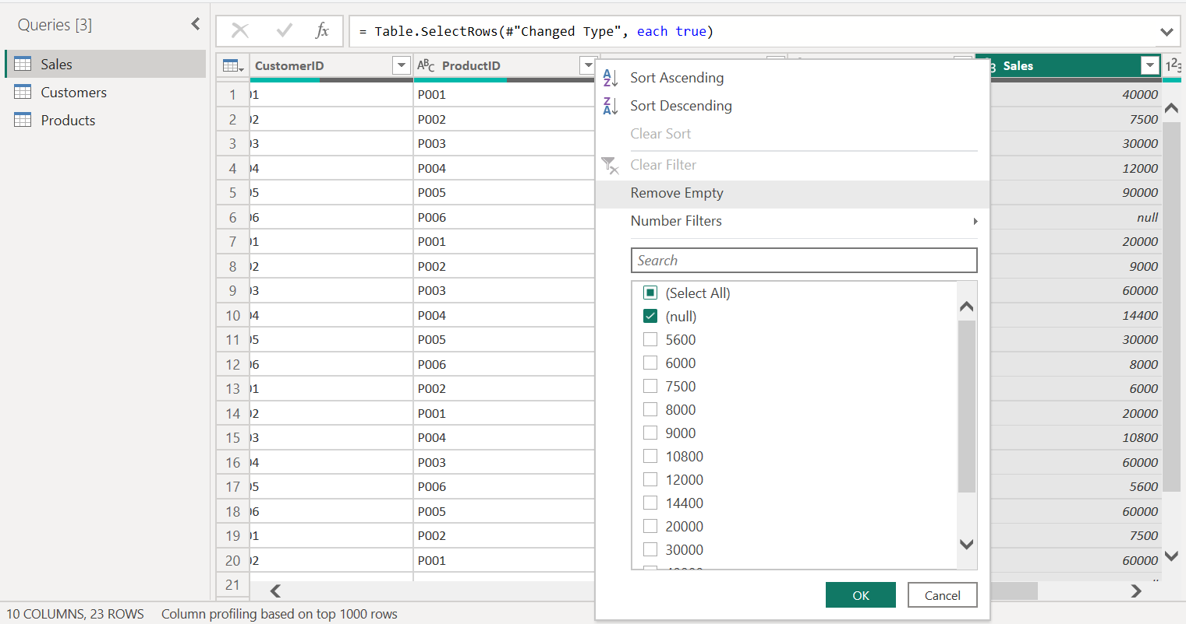
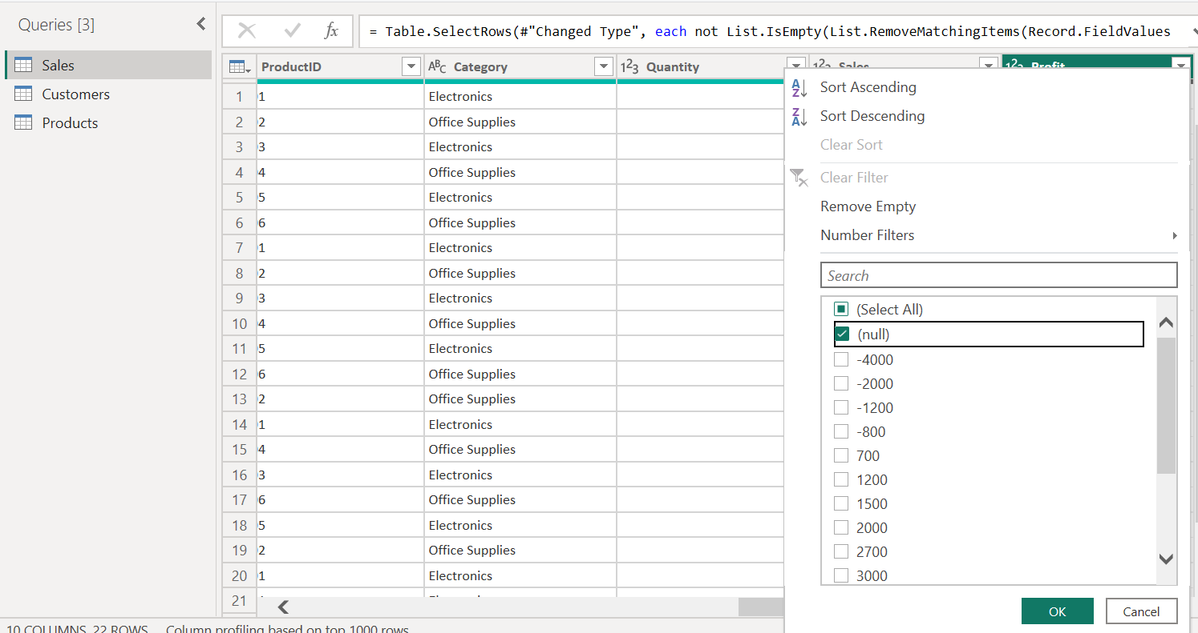

- Find duplicate values :
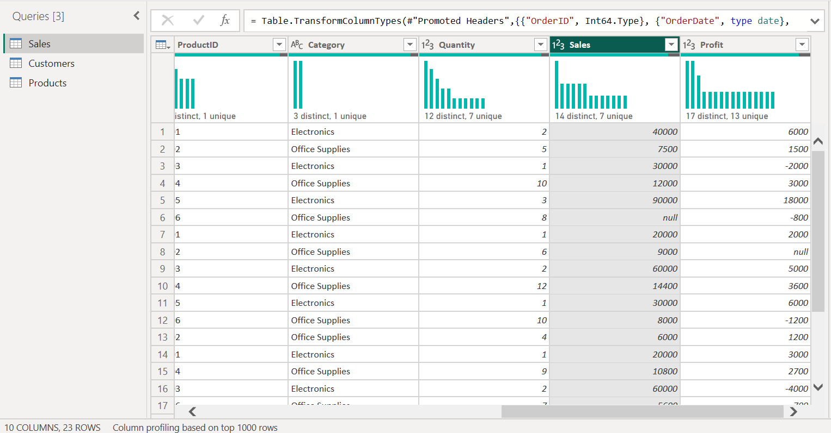
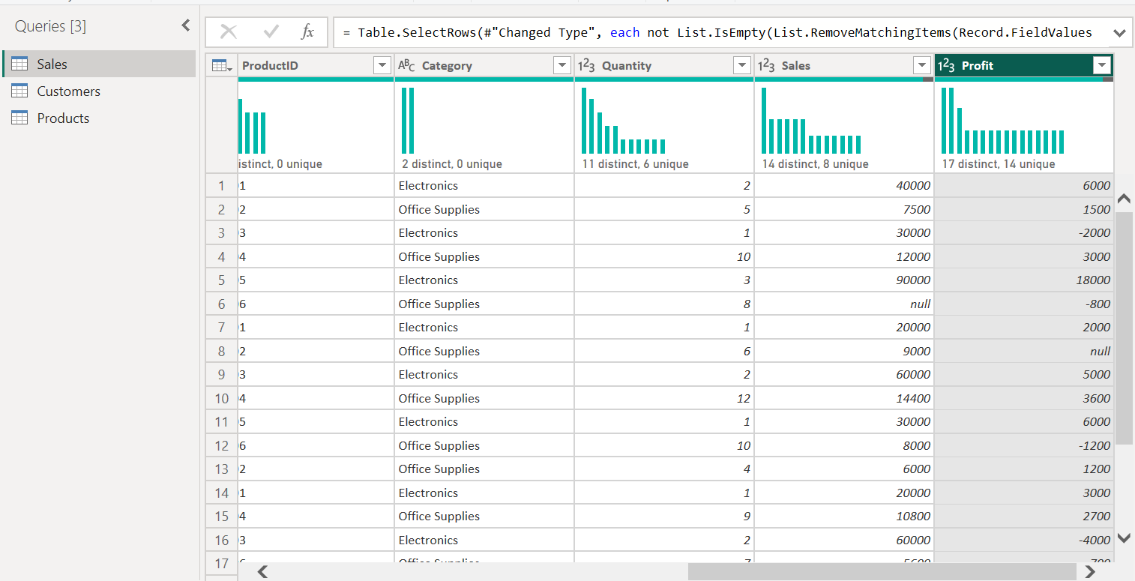

- Cleaning Steps:
- Remove missing values and replacing them :
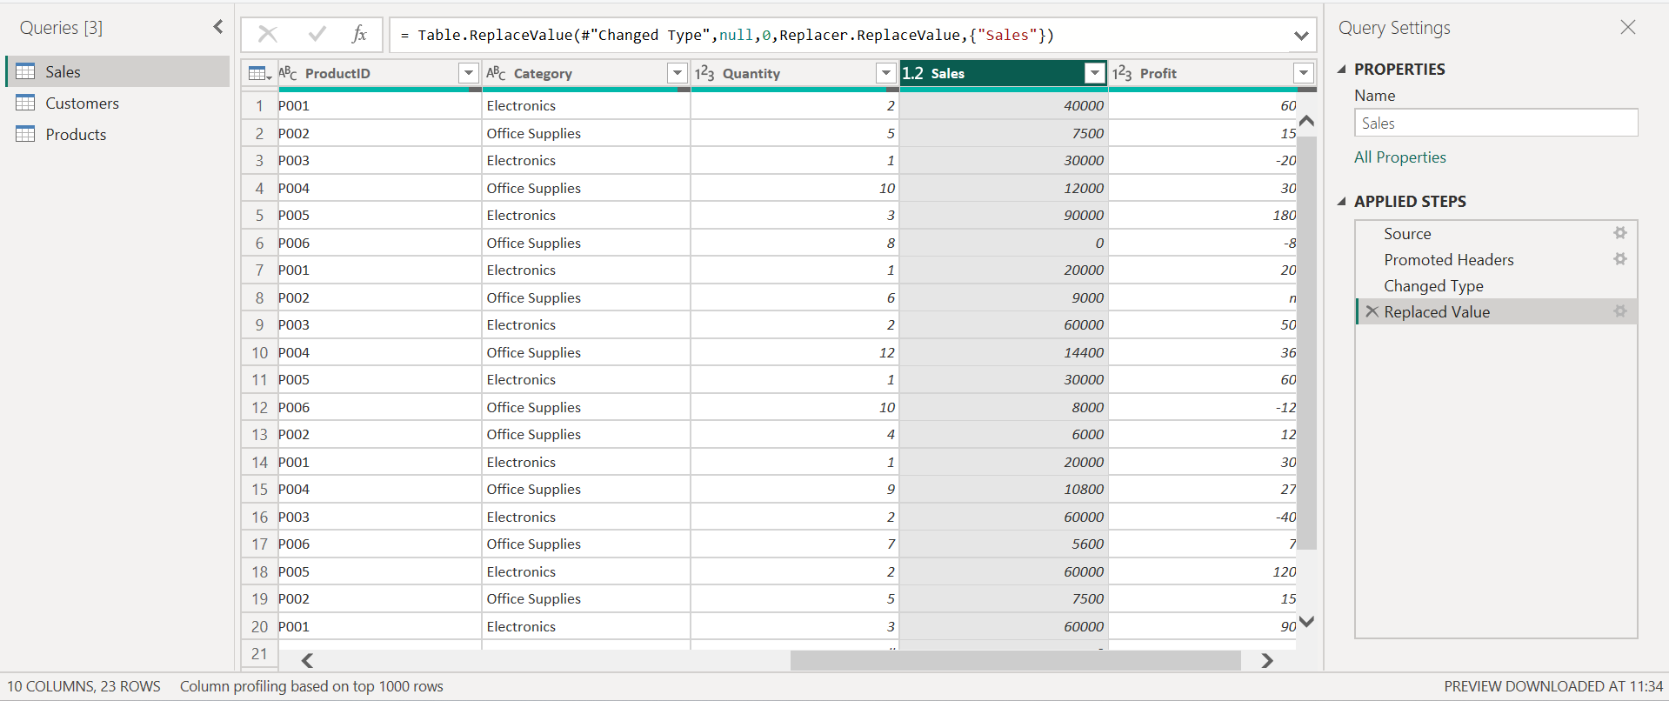

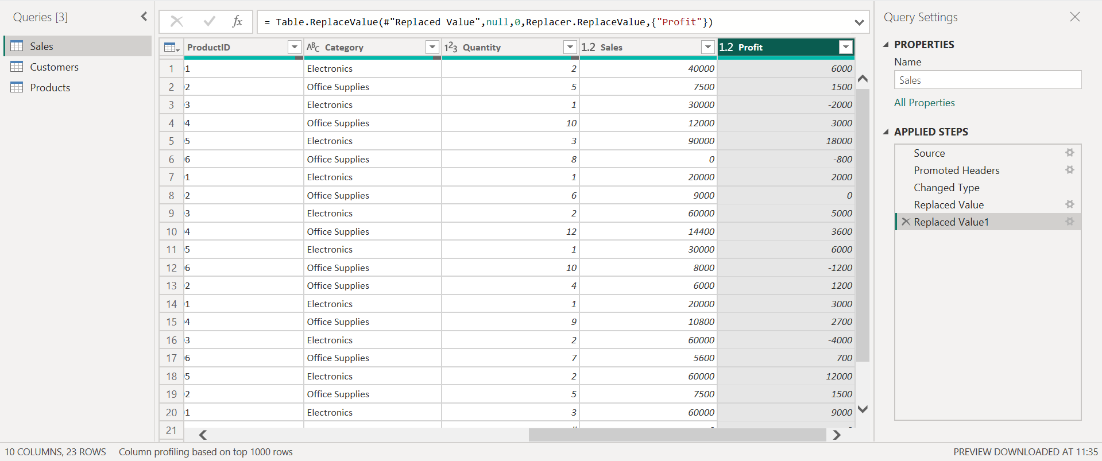

- Remove duplicate values :
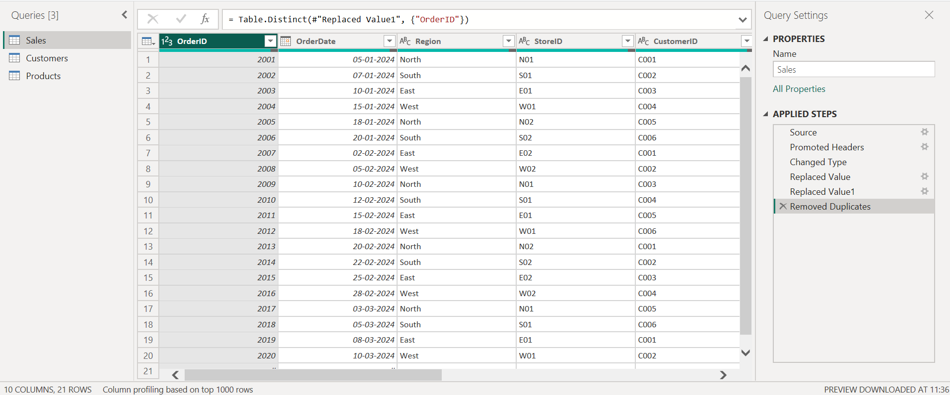
Final Output : Missing values were found in Sales and Profit columns and replaced with zero.
Duplicate records based on OrderID were removed.

2. Perform univariate analysis on Sales and Profit. What distribution patterns do you observe?
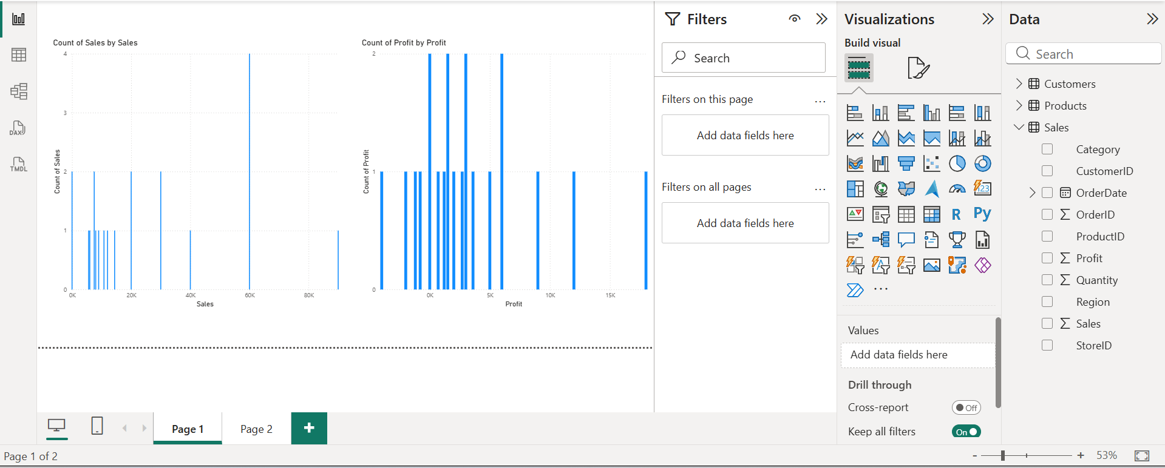
Final Output : Sales data is right-skewed, indicating that a few high-value transactions contribute most of the revenue.
Profit distribution shows variability with both positive and negative values, indicating inconsistent profitability across transactions.

- Which product categories contribute the highest revenue and profit?

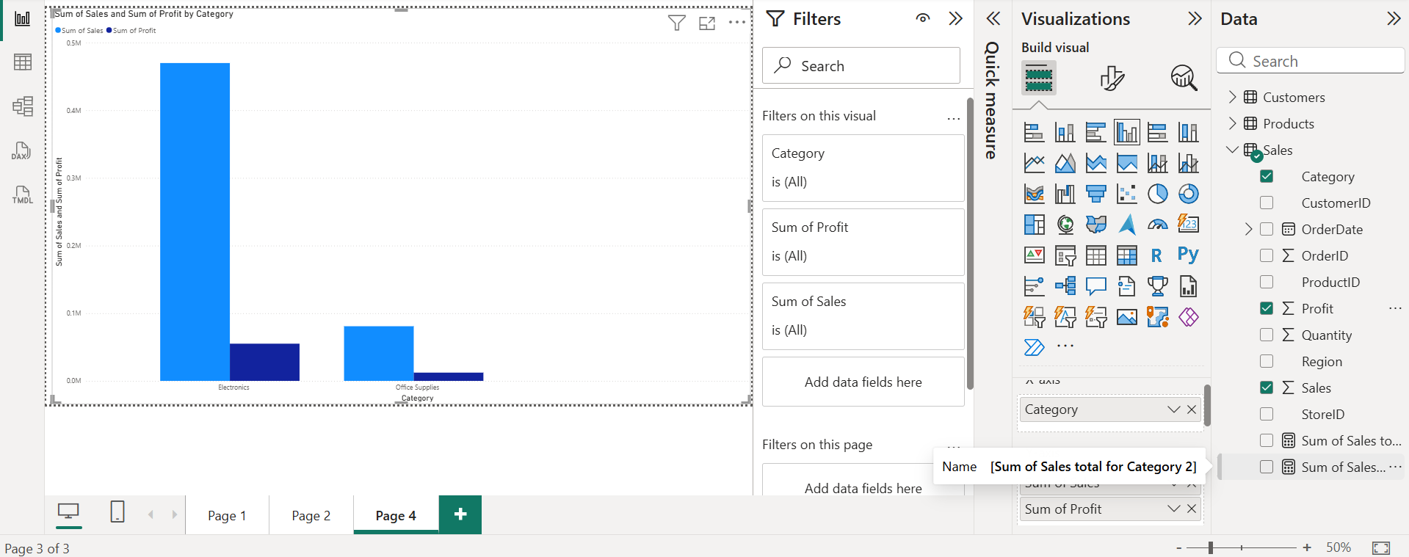
Final Output : Electronics contributes the highest revenue and profit.
Office Supplies generates lower revenue and has comparatively lower profit margins.

- How does sales performance vary across regions?
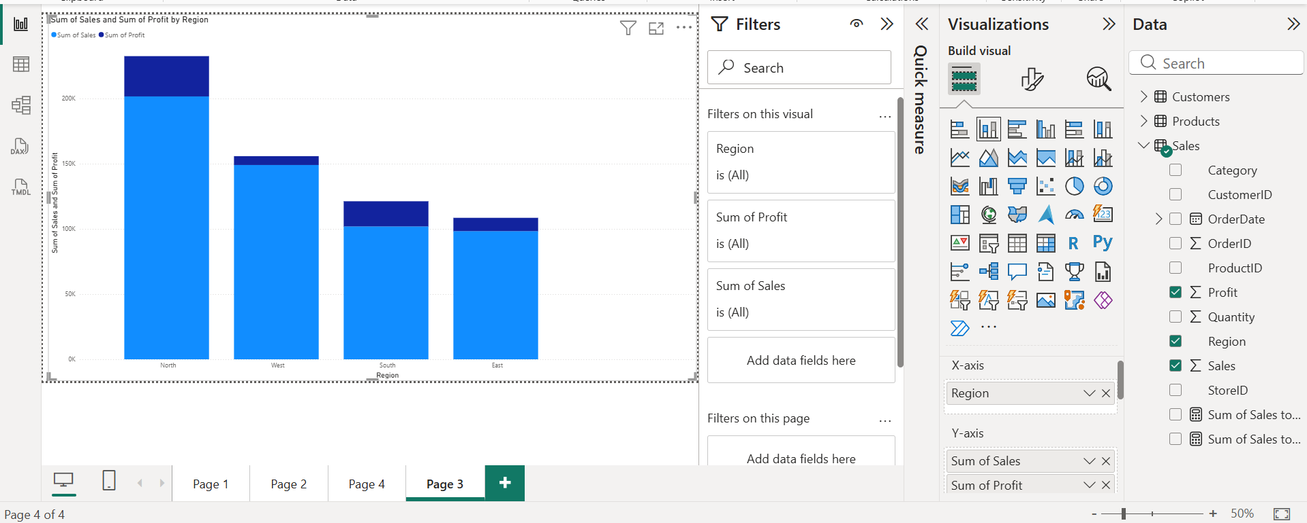
Final Output : The North region records the highest sales and profit.
South shows stable performance, while East and West experience fluctuating and lower profitability.
- Create a star schema using Sales, Customer, and Product tables. Why is this model effective?

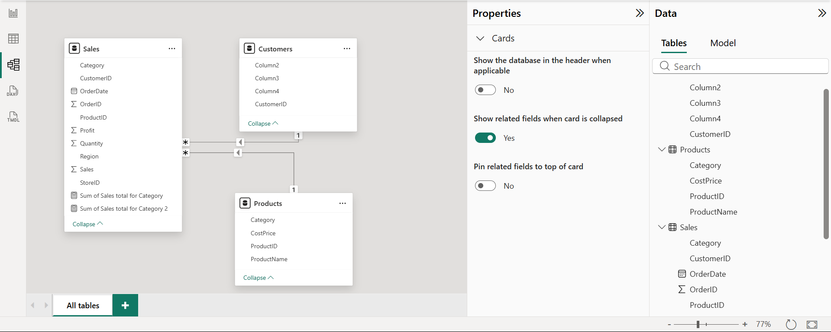
Final Output : Star schema improves query performance, simplifies data analysis, and allows easy slicing of sales data by customer and product attributes.

- Write a DAX measure to calculate Total Sales and Total Profit.
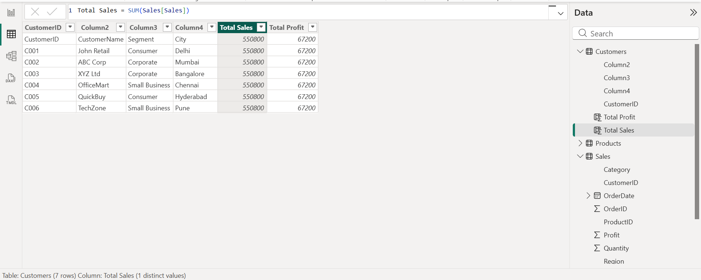

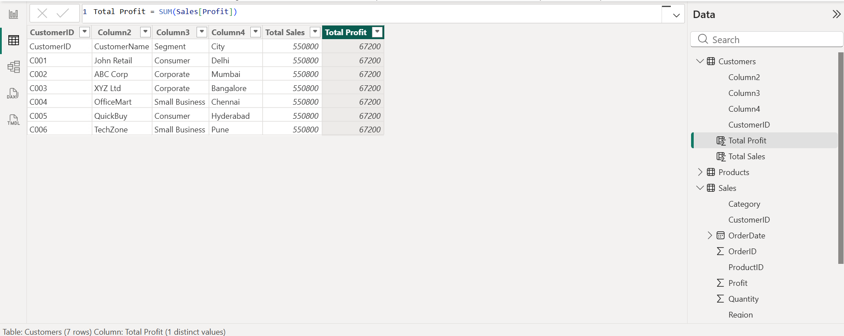
Final Output : DAX measures were created using SUM() to calculate total sales and total profit from the Sales table.

- Calculate Profit Margin (%) using DAX and identify low-margin products.
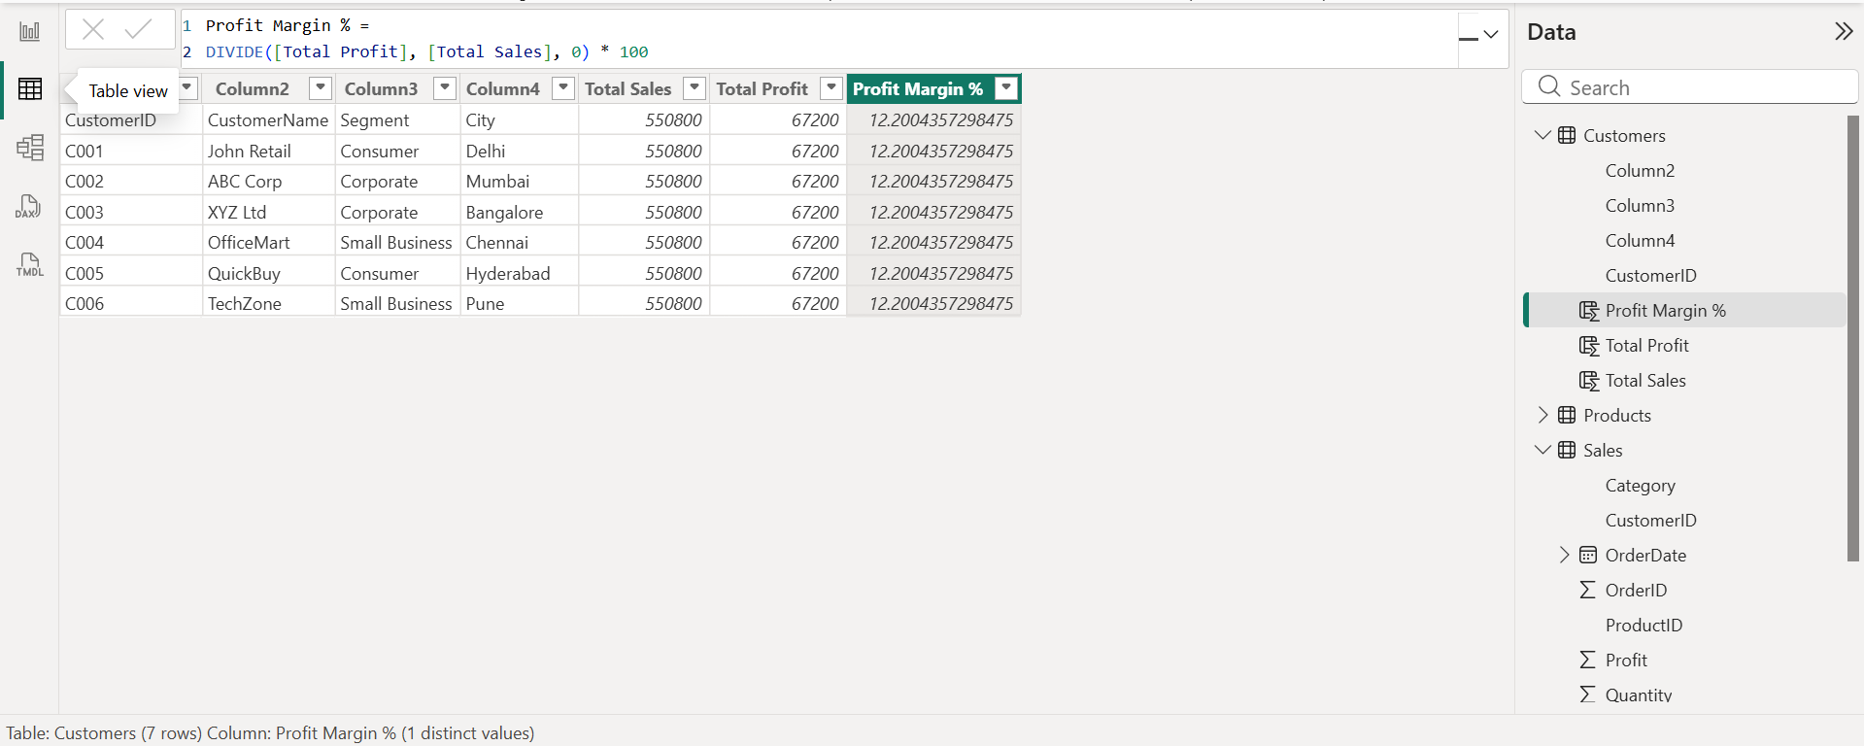

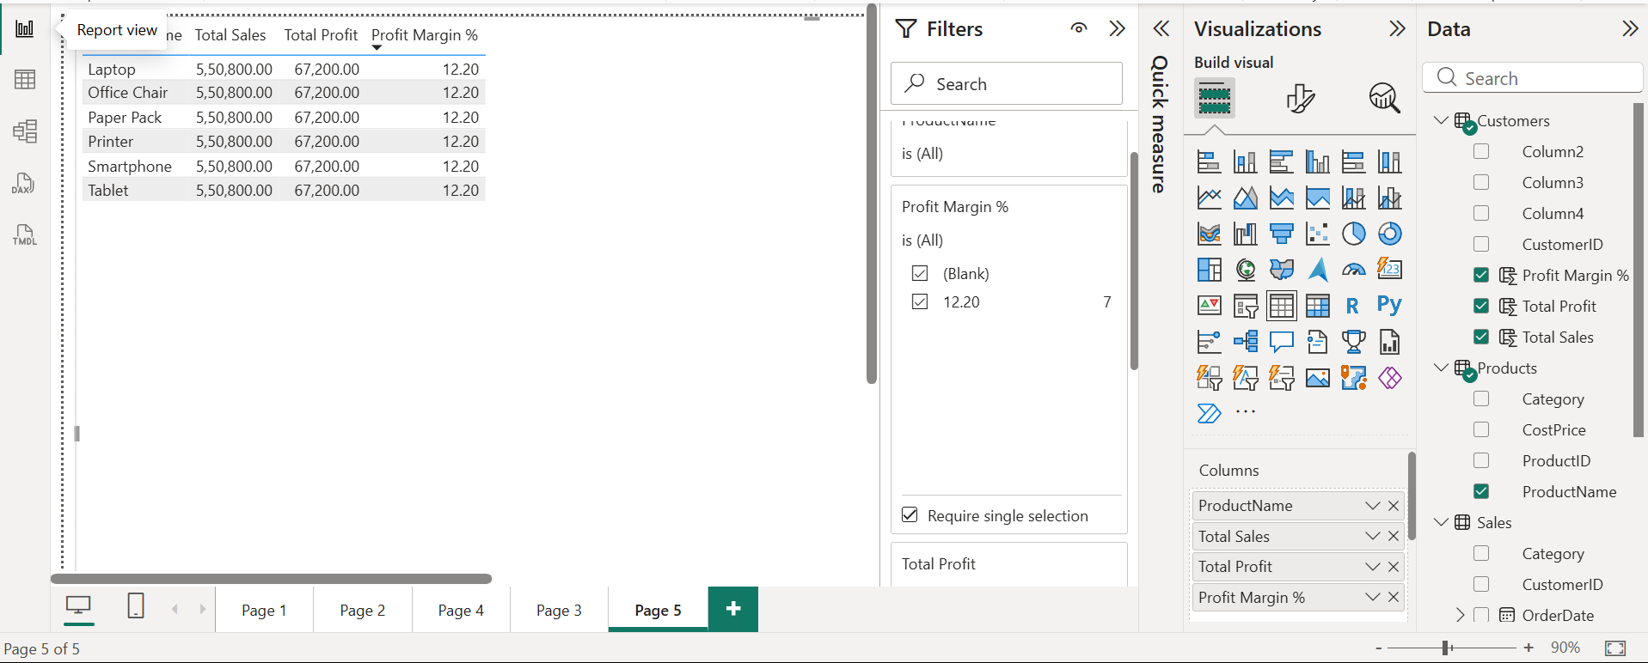
Final Output : Profit Margin (%) was calculated using DAX by dividing total profit by total sales. A table visual was used to identify low-margin products by sorting profit margin in ascending order.

- Design a dashboard to show regional and category-wise performance.
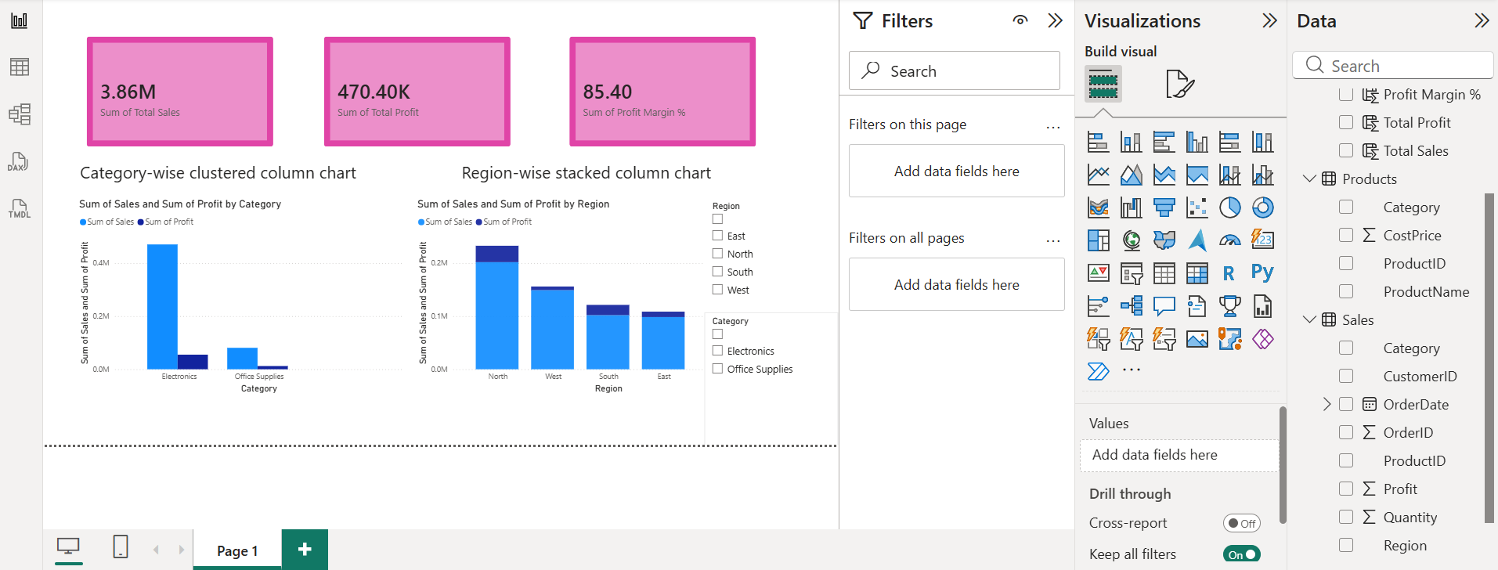
Final Output : A Power BI dashboard was created using KPI cards and charts to visualize sales and profit across regions and product categories, enabling effective performance comparison.

- Which products should be discontinued or promoted based on analysis?
Project Conclusion

- In This Project, Retail Sales Data Was Successfully Cleaned, Validated, And Analyzed Using Power Bi To Understand Revenue And Profitability Patterns Across Regions And Product Categories. Missing Values And Duplicate Records Were Handled To Ensure Data Accuracy, And A Star Schema Data Model Was Created To Improve Analytical Efficiency.

- Dax Measures Were Used To Calculate Total Sales, Total Profit, And Profit Margin, Enabling Clear Identification Of High-Performing And Low-Performing Products. The Analysis Revealed That The Electronics Category Contributes The Highest Revenue And Profit, While Certain Office Supplies Products Show Low Or Negative Profit Margins. Regional Analysis Highlighted Strong Performance In The North Region, With Other Regions Showing Inconsistent Profitability.

- An Interactive Dashboard Was Designed To Present Key Insights Through Kpi Cards, Category-Wise And Region-Wise Visualizations, Supporting Data-Driven Decision-Making. Based On The Findings, High-Margin Products Such As Laptops And Smartphones Should Be Promoted, While Low-Margin Products Like Tablets And Paper Packs Require Review Or Discontinuation.

- Overall, This Dashboard Provides Management With A Clear And Actionable View Of Business Performance, Helping Optimize Promotions, Inventory Planning, And Profitability.

Final Output : Based on profit margin analysis, low or loss-making products should be discontinued or repriced, while high-margin electronics should be promoted to maximize profitability.

